Group Contribution Form

Group Members | Contribution Level | Signatures
Hulusi Ozyahyalar | 10
Kavish Visaria-Shah | 9 | 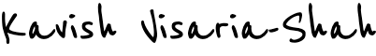
Amy Tidd | 9
Reece Ogidih | 9
Kamal Israni | 8
Radha Kumari Ray | 8

